**Week 2 – PL / SQL PROGRAMMING**

**Exercise 1: Control Structures**

**Scenario 1: The bank wants to apply a discount to loan interest rates for customers above 60 years old.**

o**Question: Write a PL/SQL block that loops through all customers, checks their age, and if they are above 60, apply a 1% discount to their current loan interest rates.**

**CODE :**

BEGIN

FOR rec IN (SELECT * FROM customers) LOOP

IF rec.age > 60 THEN

UPDATE customers

SET interest_rate = interest_rate - 1

WHERE customer_id = rec.customer_id;

END IF;

END LOOP;

COMMIT;

END;

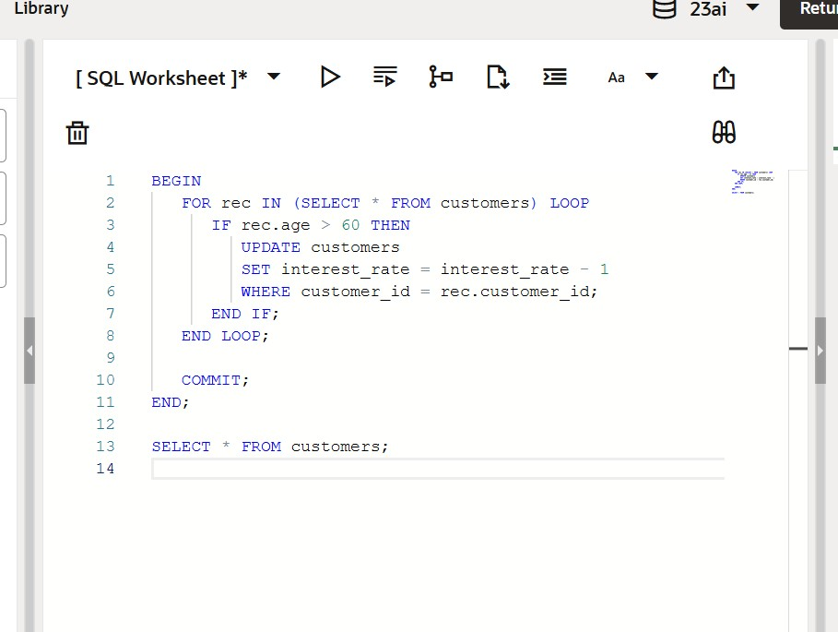

**OUTPUT :**

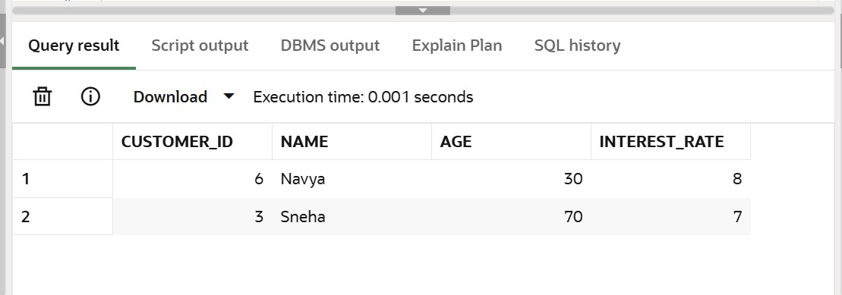

**Scenario 2: A customer can be promoted to VIP status based on their balance.**

o**Question: Write a PL/SQL block that iterates through all customers and sets a flag IsVIP to TRUE for those with a balance over $10,000.**

**CODE:**

BEGIN

FOR rec IN (SELECT * FROM customer_accounts) LOOP

IF rec.balance > 10000 THEN

UPDATE customer_accounts

SET is_vip = 'TRUE'

WHERE customer_id = rec.customer_id;

END IF;

END LOOP;

COMMIT;

END;

/

SELECT * FROM customer_accounts;

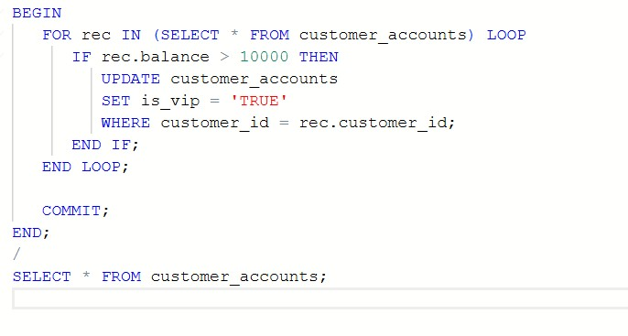

**OUTPUT :**

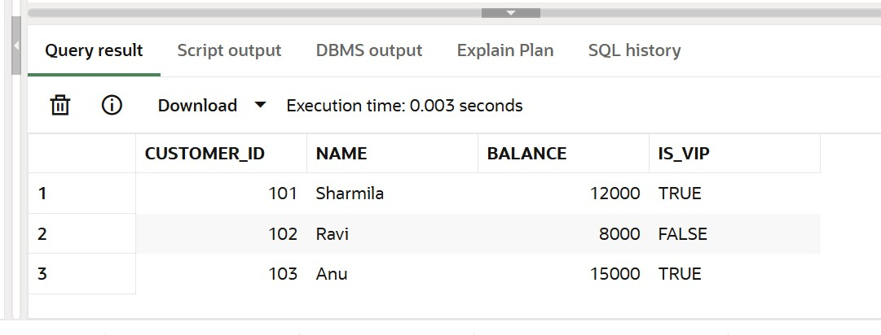

**Scenario 3: The bank wants to send reminders to customers whose loans are due within the next 30 days.**

o**Question: Write a PL/SQL block that fetches all loans due in the next 30 days and prints a reminder message for each customer.**

**CODE :**

BEGIN

FOR rec IN (SELECT * FROM loans WHERE due_date <= SYSDATE + 30) LOOP

DBMS_OUTPUT.PUT_LINE('Reminder: Loan ID ' || rec.loan_id ||

' for ' || rec.customer_name ||

' is due on ' || TO_CHAR(rec.due_date, 'DD-MON-YYYY'));

END LOOP;

END;

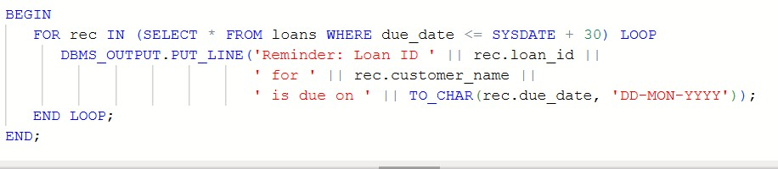

**OUTPUT :**

